Assessment Criteria
General Assessment: The following is a General Assessment Criteria.

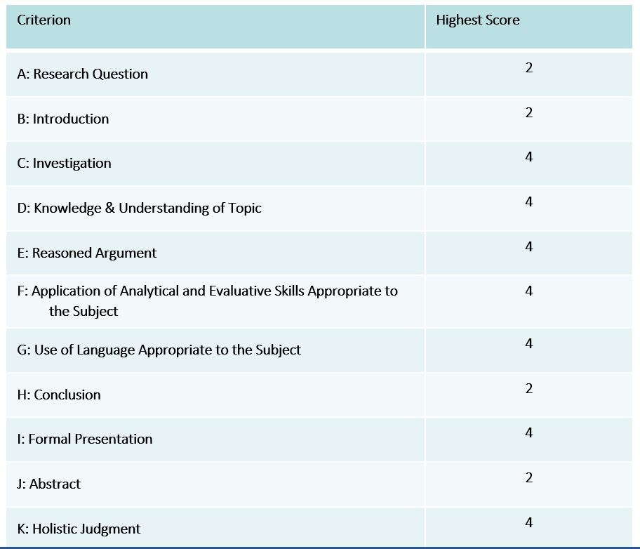

Scoring of EE
The EE is scored by an external IB-trained examiner using the assessment criteria outlined in the EE Guide.
The grade boundaries for extended essays are
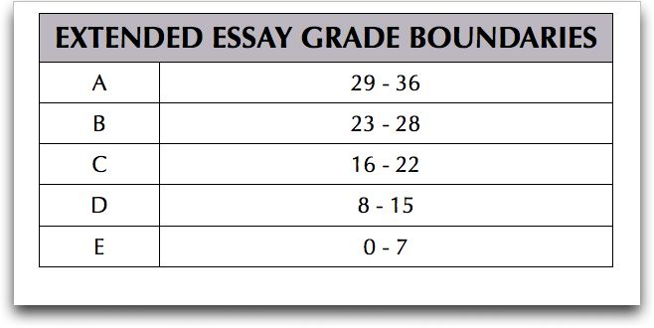
(If a student receives a score of an “N,” that means no grade was given.) Combined with the score earned on the Theory of Knowledge assessment, students may earn up to 3 bonus points, applied toward the minimum 24 points needed to earn the IB Diploma. Students who receive an “E” on either their EE or their TOK assessment must earn a minimum of 28 points to receive the IB Diploma.
Award of Diploma Points
The extended essay contributes to the overall diploma score through the award of points in conjunction with theory of knowledge. A maximum of three points are awarded according to a student’s combined performance in both the extended essay and theory of knowledge. Both the extended essay and theory of knowledge are measured against published assessment criteria. According to the quality of the work, and based on the application of these assessment criteria, a student’s performance in each of the extended essays and theory of knowledge will fall into one of the five bands described previously. The total number of points awarded is determined by the combination of the performance levels achieved by the student in both the extended essay and theory of knowledge according to the following matrix.

